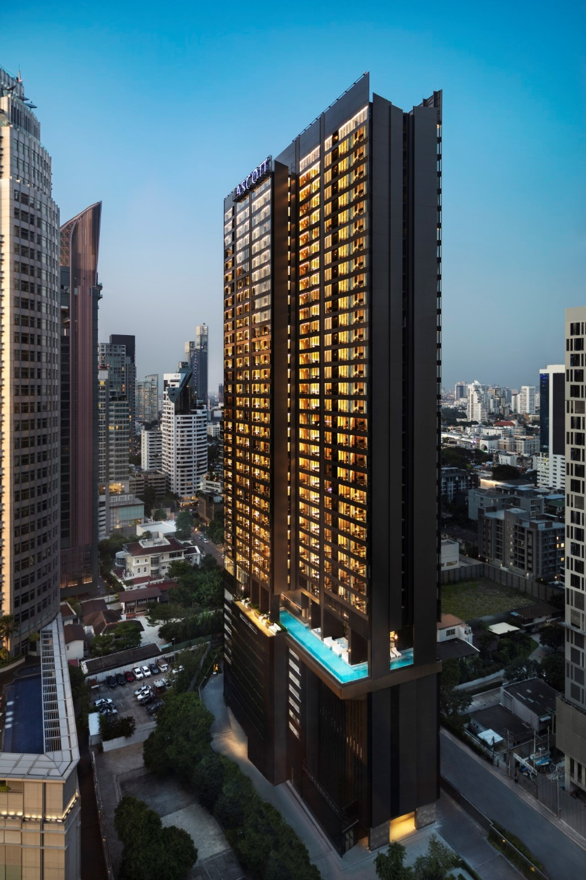

Ascott Thonglor Bangkok
Sophisticated serviced living in the heart of Thonglor
Ascott Thonglor Bangkok offers refined luxury living in one of Bangkok’s most vibrant and prestigious neighbourhoods. Designed for discerning business and leisure travellers, the property seamlessly blends spacious serviced apartments with hotel-style services, delivering comfort, privacy, and understated elegance.
Ideally located in the heart of Thonglor, guests are surrounded by renowned dining destinations, lifestyle venues, and key business hubs, making the property an ideal choice for both short-term stays and extended residences. The property features 451 elegantly designed apartments and hotel rooms, thoughtfully appointed with modern interiors, premium amenities, and fully equipped kitchenettes to support productivity and relaxation.
Facilities include a 31-metre outdoor swimming pool, a fitness centre with panoramic city views, a residents’ lounge, and a dedicated children’s playroom. Guests may also enjoy Japanese fusion cuisine at KINKI Restaurant. With its prime Sukhumvit location near BTS Thong Lo and a complimentary shuttle service, Ascott Thonglor Bangkok delivers a seamless luxury urban living experience.

